CLASS: LKG
SUBJECT: MATHEMATICS
BIG/SMALL
( DIFFERENTIATE BETWEEN BIG AND SMALL OBJECTS)

BIG | SMALL
SMALL | BIG
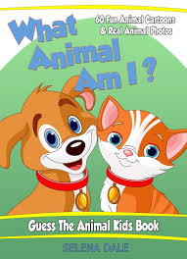 BIG | SMALL
SMALL | BIG

